Bahria University,

Karachi Campus



LAB EXPERIMENT NO.

___02___

LIST OF TASKS

|  |  |
| --- | --- |
| TASK NO | OBJECTIVE |
| **01** | List the name of all employees whose first name starts with the letter ‘A’. |
| **02** | In Customer table, display all cities that ends with the letter ‘a’. |
| **03** | Display names of all employees whose name contain ‘an’. |
| **04** | Display the company name where Region is NULL in Customer Table. |
| **05** | Write a query to list employees whose address does not contain Rd. |
| **06** | Display the highest, lowest, sum and average UnitPrice of each Category, where highest UnitPrice lies in the range of 50$ to 100$. Label column as CategoryId, Maximum, Minimum, Sum and Average, respectively. (Table: Products) |
| **07** | From customers table, Count all customers is each region where region is not null. (Table: Customers). |
| **08** | Write a query to display the number of ContactName with same ContactTitle. Sort contact title in descending order. (Table: Customers). |
| **09** | Write a query that count all orders against each product id. No of orders should be greater than 50. (Table: [Order Details]) |
| 10 | List only those cities in which more than or equals to 2 employees are living |

Submitted On:

01-03-2023

(Date: DD/MM/YY)

**Task 01:** **List the name of all employees whose first name starts with the letter ‘A’.**

**Solution:** select FirstName from Employees where FirstName like 'A%'

**Output:**

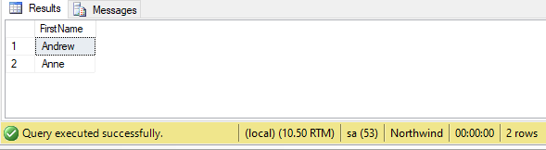

**Task 02:** **In Customer table, display all cities that ends with the letter ‘a’.**

**Solution:** select City from Customers where City like '%a'

**Output:**

**Task 03:** **Display names of all employees whose name contain ‘an’.**

**Solution:** select FirstName,LastName from Employees where FirstName like '%an%' OR LastName like '%an%'

**Output:**

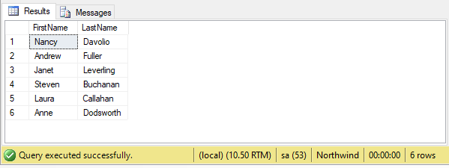

**Task 04:** **Display the company name where Region is NULL in Customer Table.**

**Solution:** select CompanyName,Region from Customers where Region is NULL

**Output:**

**Task 05:** **Write a query to list employees whose address does not contain Rd.**

**Solution:** select * from Employees where Address not like '%Rd%'

**Output:**

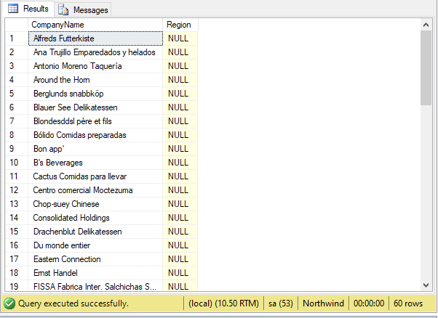

**Task 06:** **Display the highest, lowest, sum and average UnitPrice of each Category, where highest UnitPrice lies in the range of 50$ to 100$. Label column as CategoryId, Maximum, Minimum, Sum and Average, respectively. (Table: Products)**

**Solution:** select CategoryID,MAX(UnitPrice) as 'Maximum',MIN(UnitPrice) as 'Minimum',AVG(UnitPrice)as 'Average', SUM(UnitPrice) as 'Sum' from Products group by CategoryID having MAX(UnitPrice) between 50 and 100

**Output:**

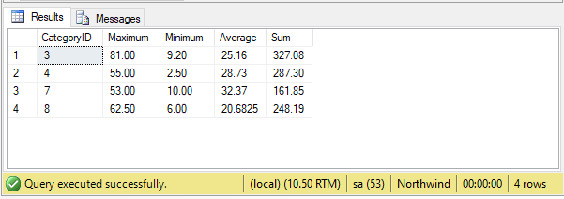

**Task 07:** **From customers table, Count all customers is each region where region is not null. (Table: Customers)**

**Solution:** select COUNT(*) as 'Count',Region from Customers where Region is NOT NULL group by Region

**Output:**

**Task 08:** **Write a query to display the number of ContactName with same ContactTitle. Sort contact title in descending order. (Table: Customers)**

**Solution:** select ContactTitle,Count(*) as Count from Customers group by ContactTitle order by ContactTitle DESC

**Output:**

**Task 09: Write a query that count all orders against each product id. No of orders should be greater than 50. (Table: [Order Details])**

**Solution:** select ProductID,COUNT(Quantity) as Quantity from [Order Details] group by ProductID having COUNT(Quantity)>50

**Output:**

**Task 10:** **List only those cities in which more than or equals to 2 employees are living**

**Solution:** select City,COUNT(City) as City from Employees group by City having COUNT(City)>=2

**Output:**

